 | Safety Bay Senior High School
CHEMISTRY UNIT 3 & 4
Test #3:
Oxidation and Reduction
NAME: |  |  | SOLUTIONS
Time allowed for this paper
Reading time: |  | 5 minutes
Working time: |  | 50 minutes
Structure of this paper:
Section |  |  | Number of questions | Marks available |  | Marks achieved
Section One:  Multiple Choice |  |  | 8 | 8
Section Two:  Short Answer |  |  | 7 | 42
 |  |  |  |  | Total | ______ / 50

Section One: Multiple Choice
Answer all questions by circling the correct option. Only circle one option for each question.

- The oxidation number for chromium in the dichromate ion (Cr₂O₇^{2–}) is:

  - +3
  - +4
  - +5
  - +6

- The oxidation number for sodium in sodium peroxide (Na₂O₂) is:

  - +1
  - +2
  - +3
  - +4

Questions 3-4 refer to the following reaction:
2 NaOH + Cℓ₂ → NaCℓ + NaCℓO + H₂O

- Which option on the table below correctly identifies the oxidant and reductant in the above reaction?

Oxidant Reductant
  - NaOH Cℓ₂
  - Cℓ₂ NaOH
  - NaOH NaOH
  - Cℓ₂ Cℓ₂

- What term is used to describe this reaction?

  - Displacement reaction
  - Acid-base reaction
  - Disproportionation reaction
  - Electrolytic reaction

- Which of the following chemical species is capable of converting Cu²⁺ into Cu(s)?

  - Pt
  - Fe
  - Au
  - HCℓ
- Which of the following describes the halogens as you go down Group 17?

  - They become stronger reductants
  - They become weaker reductants
  - They become stronger oxidants
  - They become weaker oxidants

Question 7 refers to the following electrochemical cell:

KNO₃ salt bridge
platinum electrode
copper electrode
Fe³⁺
V
Fe²⁺
SO₄²⁻
Cu²⁺
SO₄²⁻

Reduction half-equations:
Fe³⁺ + e⁻ → Fe²⁺ E° = 0.77 V
Cu²⁺ + 2 e⁻ → Cu E° = 0.34 V

- Which of the following equations would be used to calculate the voltage of the cell under standard conditions?

(a) | $${E°}_{cell}=\left(0.77\right)-\left(0.34\right)=0.43 V$$
(b) | $${E°}_{cell}=\left(0.77\right)+\left(0.34\right)=1.11 V$$
(c) | $${E°}_{cell}=\left(2×0.77\right)-\left(0.34\right)=1.20 V$$
(d) | $${E°}_{cell}=\left(2×0.77\right)+\left(0.34\right)=1.88 V$$

- Why does the hydrogen half-equation (2 H⁺ + 2 e⁻ → H₂) have a standard reduction potential of 0.000 V?

  - The value has been measured very precisely
  - It is an arbitrary set reference
  - Hydrogen ions have no ability to attract electrons
  - The half-cell cannot produce current

Section Two: Short Answer
Write your answers in the spaces provided.
- (7 marks)

  - Write balanced ionic equations, including state symbols, for the following reactions: (3 marks)

Answer | Cumulative Marks
Zn(s) + Ni²⁺(aq) → Zn²⁺(aq) + Ni(s) | 1 mark
F₂(g) + 2 I⁻(aq) → 2 F⁻(aq) + I₂(aq) | 1 mark
Correct use of state symbols, ionic equations | 1 mark
TOTAL: | 3 marks

  - Explain why the reaction in Q9(a) is considered a ‘redox’ reaction. (2 marks)

Answer | Cumulative Marks
Zn loses two electrons and is oxidised | 1 mark
Ni²⁺ gains two electrons and is reduced | 1 mark
TOTAL: | 2 marks

  - Describe what would be observed in the beaker as the reaction in Q9(a) occurs. (2 marks)

Answer | Cumulative Marks
Green colour of solution fades | 1 mark
Grey/silver/black solid forms on outside of zinc | 1 mark
TOTAL: | 2 marks

- (4 marks)
The following reaction shows a process used in the extraction and purification of gold:

Au(s) + 3 HNO₃(aq) + 4 HCℓ(aq) → HAuCℓ₄(aq) + 3 NO₂(g) + 3 H₂O(ℓ)

Identify the oxidising agent and reducing agent in this reaction. Give evidence to support your answer.

Answer | Cumulative Marks
Au(s) is reducing agent.  It causes the N in HNO₃ to be reduced from +5 to +4 | 1 mark  1 mark
HNO₃(aq) is the oxidising agent  It causes the Au in Au(s) to be oxidised from +0 to +3 | 1 mark  1 mark
TOTAL: | 4 marks

Award 3/4 if students misread question and instead correctly identify and explain what is oxidised and what is reduced (rather than identify the oxidising agent and reducing agent).

- (7 marks)
A galvanic cell was constructed as shown in the diagram below:
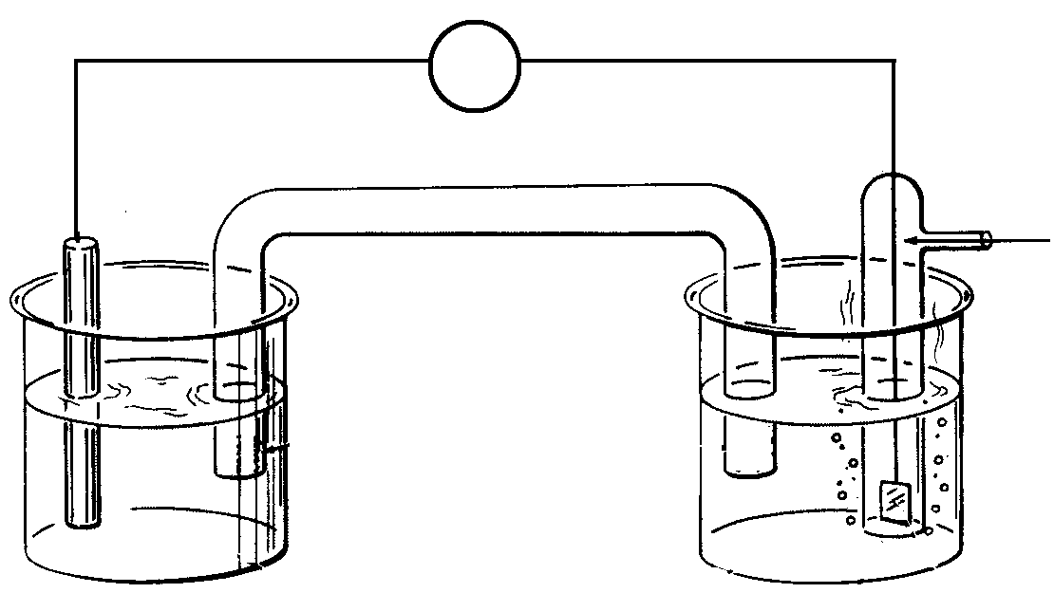
KCℓ(aq)
Cℓ₂(g)
Pt(s)
Cr(s)
V
Salt bridge (NH₄Cℓ)
CrCℓ₃(aq)
A
B

  - Write the oxidation and reduction half-equations, and a balanced overall redox equation for this reaction. (3 marks)

Answer | Cumulative Marks
Oxidation: Cr(s) → Cr³⁺(aq) + 3 e⁻ | 1 mark
Reduction: Cℓ₂(g) + 2 e⁻ → 2 Cℓ⁻(aq) | 1 mark
Overall: 2 Cr(s) + 3 Cℓ₂(g) → 2 Cr³⁺(aq) + 6 Cℓ⁻(aq) | 1 mark
TOTAL: | 3 marks
Award 2/3 if half-equations are correct but are placed in the wrong boxes.

  - Name the anode and cathode in the above cell: (2 marks)

Answer | Cumulative Marks
Anode: Chromium | 1 mark
Cathode: Platinum | 1 mark
TOTAL: | 2 marks

  - Between the points labelled A and B, show the direction of electron flow. (1 mark)

Answer | Cumulative Marks
A B | 1 mark
TOTAL: | 1 mark

  - Show on the diagram the direction of ion flow in the salt bridge. (1 mark)

Answer | Cumulative Marks
Cℓ⁻ NH₄⁺ | 1 mark
TOTAL: | 1 mark

- (6 marks)
The following diagram shows a form of electrolysis:
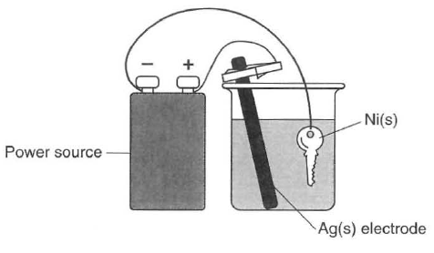
  - Give the name of this application of electrolysis, and describe its purpose in this particular scenario. (2 marks)

Answer | Cumulative Marks
Electroplating OR metal plating | 1 mark
To coat the key with a layer of silver | 1 mark
TOTAL: | 2 marks

  - Write half-equations showing the process occurring at the: (2 marks)

Answer | Cumulative Marks
Anode: Ag(s) → Ag⁺(aq) + e⁻ | 1 mark
Cathode: Ag⁺(aq) + e⁻ → Ag(s) | 1 mark
TOTAL: | 2 marks
Award 1/2 if equations correct but in wrong boxes.

  - Give the name or formula of a suitable electrolyte for this cell. (1 mark)

Answer | Cumulative Marks
Silver nitrate (AgNO₃) OR silver ethanoate (AgCH₃COO) | 1 mark
TOTAL: | 1 mark

  - What is the purpose of the power source in this cell? (1 mark)

Answer | Cumulative Marks
(Provide a potential difference to) force a non-spontaneous redox reaction to occur | 1 mark
TOTAL: | 1 mark

- (4 marks)
‘Breathalysers’ are instruments used by police to measure the concentration of ethanol (C₂H₅OH) in a driver’s breath. One type of breathalyser used is a fuel cell. If the driver’s breath contains ethanol then a redox reaction will occur. The ethanol reacts to form ethanoic acid (CH₃COOH) and oxygen from the air reacts to form water vapour. Both reactions occur in acidic conditions.

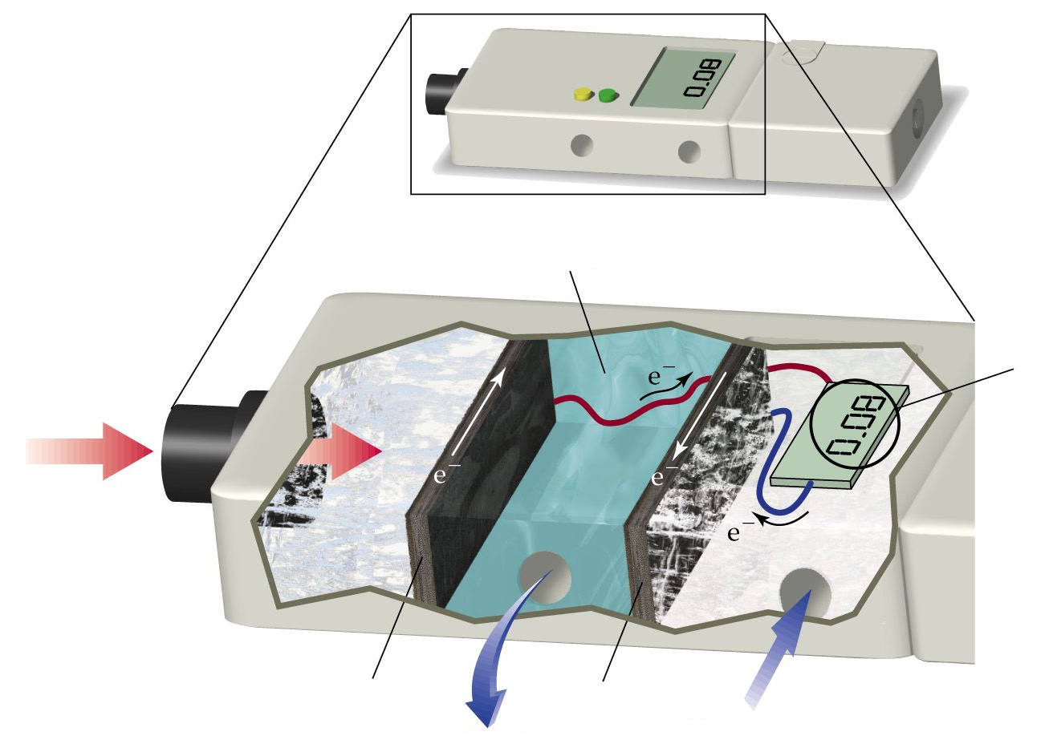
C₂H₅OH
acidic electrolyte
air
intake
O₂
waste
products
Driver’s
breath
Blood alcohol level
Electrode
(positive)
Electrode
(negative)

  - Complete the half-equations below to show the reactions occurring in each section of the breathalyser. Both reactions occur in acidic conditions. (4 marks)

Answer | Cumulative Marks
H₂O + C₂H₅OH → CH₃COOH + 4 H⁺ + 4 e⁻ | 2 marks
4 e⁻ + 4 H⁺ + O₂ → 2 H₂O | 2 marks
TOTAL: | 4 marks
Deduct 1 mark per mistake. Follow through balancing H₂O, H⁺, e⁻.

  - Label the diagram to show the charges of the two electrodes. (1 mark)
Answer | Cumulative Marks
Left-hand electrode (anode) is negative  Right-hand electrode (cathode) is positive | 1 mark
TOTAL: | 1 mark

  - What characteristic of this breathalyser allows it to be classified as a “fuel cell”? (1 mark)

Answer | Cumulative Marks
There is a continuous supply of reactants | 1 mark
TOTAL: | 1 mark

- (4 marks)
The lithium button cell, used to power watches and calculators, is a primary cell containing lithium metal. The lithium ion cell is a secondary cell that is used to power laptops.
 | 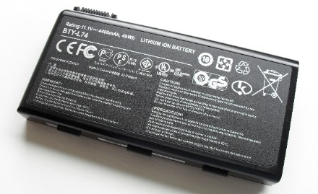
Lithium button cell | Lithium ion cell

The half-equation for the reduction of lithium is:
Li⁺(aq) + e⁻ → Li(s) E° = -3.04 V

  - What is the difference between a primary and secondary cell? (1 mark)

Answer | Cumulative Marks
Seconds cells can be recharged. Primary cells cannot. | 1 mark
TOTAL: | 1 mark

  - Give one reason why lithium is used as a reactant in these galvanic cells. (1 mark)

Answer | Cumulative Marks
Any one of following:  - Lithium is a strong reductant  - Li⁺(aq)/Li(s) has a (very) low E° value  - Lithium is more readily oxidised than other substances  - Lithium cells produce high voltages | 1 mark
TOTAL: | 1 mark

Some early lithium metal batteries exploded when exposed to water.

  - Write a balanced equation for the reaction between lithium metal and water and explain why an explosion may occur. (2 marks)

Answer | Cumulative Marks
2 H₂O(ℓ) + 2 Li(s) → H₂(g) + 2 OH⁻(aq) + 2 Li⁺(aq) | 1 mark
Can cause an explosion due to build-up of pressure from gas  and/or  Can cause an explosion because the hydrogen gas produced is flammable | 1 mark
TOTAL: | 1 mark

- (8 marks)
The bromate ion (BrO₃⁻) is an ion formed by the ozonation of drinking water. Bromate ion is a powerful oxidising agent and can react in the presence of an acid to form bromine (Br₂).
  - Write a half-equation showing the reduction of the bromate ion to form bromine. (2 marks)

Answer | Cumulative Marks
2 BrO₃⁻(aq) + 12 H⁺(aq) + 10 e⁻ → Br₂(aq) + 6 H₂O(ℓ) | 2 marks
TOTAL: | 2 marks
Deduct 1 mark per mistake. Follow through balancing H₂O, H⁺, e⁻.

  - Information about the oxidising power of the bromate ion can be gathered by observing what other species it is able to react with.

A student constructed the following two electrochemical cells and allowed each cell to operate for five minutes. In their notes they recorded the initial and final appearance of each half-cell. All cells were constructed under standard conditions.

Electrochemical Cell #1 (EC1): Electrochemical Cell #2 (EC2):

salt bridge
C(s)
BrO₃⁻(aq)
Cr³⁺(aq)
C(s)
salt bridge
C(s)
BrO₃⁻(aq)
Mn²⁺(aq)
C(s)
Initial appearance:
Pale pink solution

Final appearance:
Pale pink solution
Initial appearance:
Colourless solution

Final appearance:
Colourless solution
Initial appearance:
Green solution

Final appearance:
Orange solution
Initial appearance:
Colourless solution

Final appearance:
Brown solution

    - Account for the colour changes in EC1 (Electrochemical Cell #1). (3 marks)

Answer | Cumulative Marks
Brown colour is due to the production of Br₂(aq) | 1 mark
Colour change from green to orange shows Cr³⁺ is reacting to make Cr₂O₇²⁻ | 1 mark
(Supports answer with relevant half-equation)  2 Cr³⁺(aq) + 7 H₂O(ℓ) → Cr₂O₇²⁻(aq) + 14 H⁺(aq) + 6e⁻ | 1 mark
TOTAL: | 3 marks

    - Explain how the observations in EC1 and EC2 can be used to gain information about the standard reduction potential (E°) of bromate ions. (3 marks)

In EC1, BrO₃⁻ was able to oxidise Cr³⁺ to Cr₂O₇²⁻. This means that BrO₃⁻ is a more powerful oxidant than Cr₂O₇²⁻, and has a standard reduction potential (E°) > +1.36 V.

In EC2, there was no reaction. This indicates that BrO₃⁻ was not able to oxidise Mn²⁺ to MnO₄⁻. BrO₃⁻ is a weaker oxidant than MnO₄⁻, and therefore has a standard reduction potential (E°) < +1.51 V.

Combining this information tells us that the reduction potential of BrO₃⁻ is somewhere between +1.36 V and +1.51 V.

Answer | Cumulative Marks
Uses EC1 to determine E°(BrO₃⁻) > +1.36 V | 1 mark
Uses observations from EC2 to determine that Mn²⁺ was not reduced to MnO₄⁻ | 1 mark
Uses EC2 to determine E°(BrO₃⁻) < +1.51 V | 1 mark
TOTAL: | 3 marks

